The Boys of Summer Honor Fallen Heroes
The Broadway Bruins paid tribute to combat Soldiers killed in action; Billy Pangle and Bucky Anderson.
Vietnam Veterans of America Chapter 1061 Harrisonburg Virginia was honored to present the Colors for two local fallen heroes.

Billy Pangle graduated from Broadway High School in 1966 and had played football for Broadway High School.
Billy was the only 1966 graduate from Broadway High School to be killed in action during the Vietnam War and honored with a bronze plaque at J.Frank Hillyard Middle School in Broadway Virginia.
Billy served his country with honor and was killed in action in Vietnam on April 23, 1968, and paid the ultimate sacrifice for freedom serving his Country in the United States Marine Corps.

Bucky Anderson graduated from Broadway High School in 2004 and was a two-time State Wrestling champion for Broadway High School.
Bucky was a member of the 10th Mountain Division of the United States Army. Bucky served his country with honor and was killed in action in Afghanistan on June 12. 2010 when an IED exploded while on patrol and paid the ultimate sacrifice for freedom serving his Country in the United States Army.

Vietnam Veterans of America Chapter 1061 had 22 members attend the pregame ceremony and presented the Colors while Taps and the National Anthem were played.

Never again will one generation abandon another

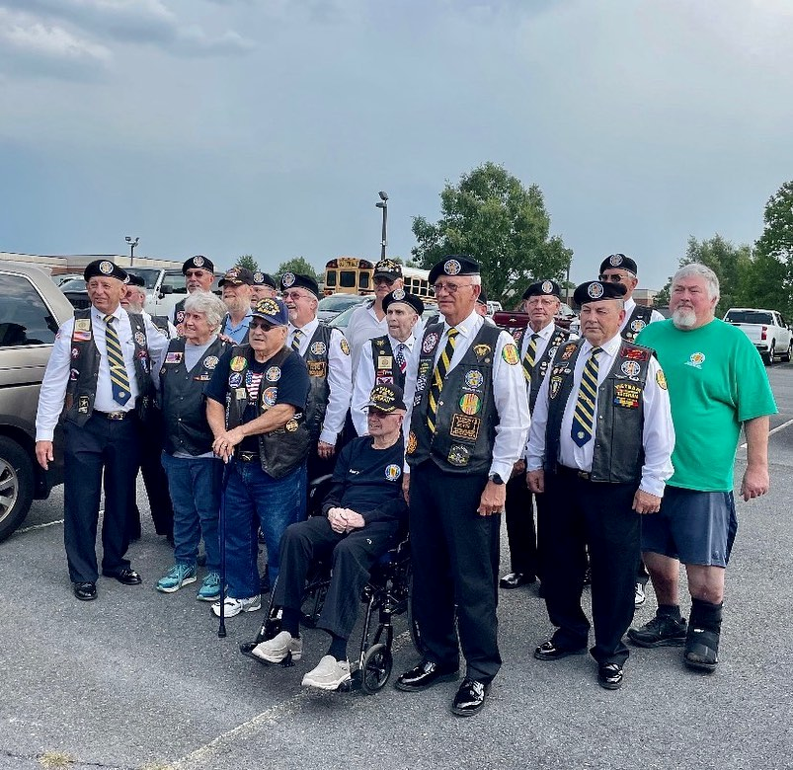

Thomas R. Snook, Secretary
VVA Chapter 1061

